Bahria University,

Karachi Campus



LAB EXPERIMENT NO.

8

_______

LIST OF TASKS

|  |  |
| --- | --- |
| TASK NO | OBJECTIVE |
| 01 | Create a payroll system using classes, inheritance and polymorphism |
| 02 | You have to implement the following diagram including some attributes and other functions: |

Submitted On:

____________

(Date: DD/MM/YY)

**Task 1:**

Create a payroll system using **classes**, **inheritance** and **polymorphism**

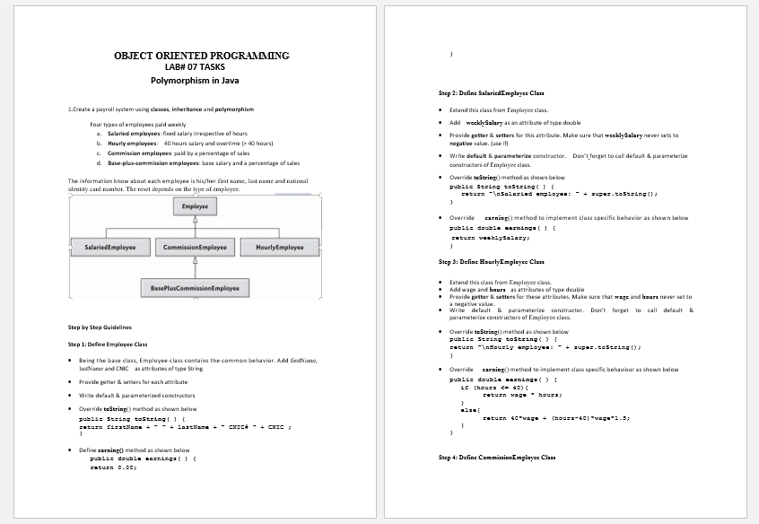 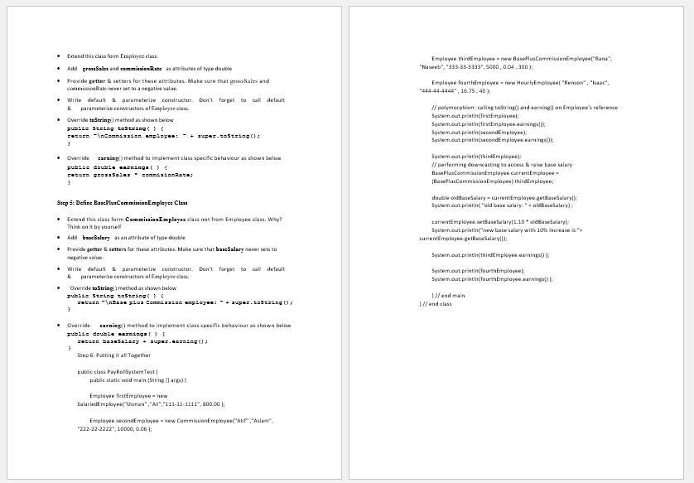

**Solution:**

package oop_lab_8;

public class OOP_LAB_8 {

public static void main(String[] args) {

Employee firstEmployee = new SalariedEmployee("Usman" ,"Ali","111-11-1111", (long) 800.00);

Employee secondEmployee = new ComissionEmployee("Atif" ,"Aslam", "222-22-2222", 10000, 0.06 );

Employee thirdEmployee = new BasePlusComissionEmployee("Rana", "Naseeb", "333-33-3333", 5000 , 0.04 , 300 );

Employee fourthEmployee = new HourlyEmployee( "Renson" , "Isaac", "444-44-4444" , (long) 16.75, 40 );

System.out.println(firstEmployee);

System.out.println(firstEmployee.Earnings());

System.out.println(secondEmployee);

System.out.println(secondEmployee.Earnings());

System.out.println(thirdEmployee);

BasePlusComissionEmployee currentEmployee = (BasePlusComissionEmployee) thirdEmployee;

double oldBaseSalary = currentEmployee.getBaseSalary();

System.out.println("Old Base Salary: "+ oldBaseSalary);

currentEmployee.setBaseSalary(1.10 * oldBaseSalary);

System.out.println("New Base Salary with 10% increase is: "+ currentEmployee.getBaseSalary());

System.out.println(thirdEmployee.Earnings() );

System.out.println(fourthEmployee);

System.out.println(fourthEmployee.Earnings() );

}

}

package oop_lab_8;

public class Employee {

private String firstName;

private String lastname;

private String nicNumber;

public Employee(){

this.firstName=" ";

this.lastname=" ";

this.nicNumber=" ";

}

public Employee(String fn, String ln, String ni){

this.firstName=fn;

this.lastname=ln;

this.nicNumber=ni;

}

public void setFirstName(String f){

this.firstName=f;

}

public String getFirstName(){

return this.firstName;

}

public void setLastName(String l){

this.lastname=l;

}

public String getLastName(){

return this.lastname;

}

public void setNICNumber(String num){

this.nicNumber=num;

}

public String getNICNumber(){

return this.nicNumber;

}

public String toString(){

return "\nFirst Name: "+this.firstName+"\nLast Name: "+this.lastname+"\nCNIC Number: "+this.nicNumber;

}

public double Earnings(){

return 0.0;

}

}

package oop_lab_8;

public class SalariedEmployee extends Employee{

public long weeklySalary;

public SalariedEmployee(){

this.weeklySalary=0;

}

public SalariedEmployee(String fn, String ln, String ni, long s){

super(fn,ln,ni);

this.weeklySalary=s;

}

public void setSalary(long sa){

if(sa < 0){

System.out.println("ERROR! \n Salary can't be in Negative!!");

}

else {

this.weeklySalary=sa;

}

}

public long getSalary(){

return this.weeklySalary;

}

public String toString( ) {

return "\nSalaried Employee: " + super.toString();

}

public double Earnings( ) {

return weeklySalary;

}

}

package oop_lab_8;

public class HourlyEmployee extends Employee{

private long wage;

private double hours;

public HourlyEmployee(){

this.wage=0;

this.hours=0;

}

public HourlyEmployee(String fn, String ln, String ni, long w, double h){

super(fn,ln,ni);

this.wage=w;

this.hours=h;

}

public void setWage(long wa){

if(wa < 0){

System.out.println("ERROR! \n Wage can't be in Negative!!");

}

else {

this.wage=wa;

}

}

public long getWage(){

return this.wage;

}

public void setHours(double ho){

if(ho<0){

System.out.println("ERROR! \n Hours can't be in Negative!!");

}

else {

this.hours=ho;

}

}

public double getHours(){

return this.hours;

}

public String toString( ) {

return "\nHourly Employee: " + super.toString();

}

public double Earnings( ) {

if (hours <= 40){

return wage * hours;

}

else{

return 40*wage + (hours-40)*wage*1.5;

}

}

}

package oop_lab_8;

public class BasePlusComissionEmployee extends ComissionEmployee{

private double baseSalary;

public BasePlusComissionEmployee(){

this.baseSalary=0;

}

public BasePlusComissionEmployee(String fn, String ln, String ni, double gs, double cr,double bs){

super(fn,ln,ni,gs,cr);

this.baseSalary=bs;

}

public void setBaseSalary(double bs){

if(bs < 0){

System.out.println("ERROR! \n Base Salary can't be in Negative!!");

}

else{

this.baseSalary=bs;

}

}

public double getBaseSalary(){

return this.baseSalary;

}

public String toString( ) {

return "\nBase plus Commission Employee: " + super.toString();

}

public double Earnings( ) {

return baseSalary + super.Earnings();

}

}

package oop_lab_8;

public class ComissionEmployee extends Employee{

private double grossSales;

private double commisionRate;

public ComissionEmployee(){

this.grossSales=0;

this.commisionRate=0;

}

public ComissionEmployee(String fn, String ln, String ni, double gs, double cr){

super(fn,ln,ni);

this.grossSales=gs;

this.commisionRate=cr;

}

public void setGrossSales(double g){

if(g < 0){

System.out.println("ERROR! \n Gross Hours can't be in Negative!!");

}

else{

this.grossSales=g;

}

}

public double getGrossSales(){

return this.grossSales;

}

public void setComissionRates(double c){

if(c < 0){

System.out.println("ERROR! \n Comission Rates can't be in Negative!!");

}

else{

this.commisionRate=c;

}

}

public double getComissionRates(){

return this.commisionRate;

}

public String toString( ) {

return "\nCommission Employee: " + super.toString();

}

public double Earnings( ) {

return grossSales * commisionRate;

}

}

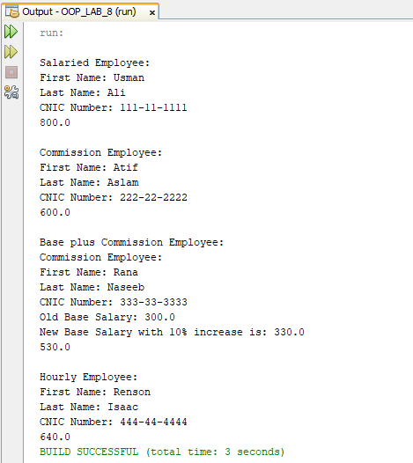

**Task 2:**

You have to implement the following diagram including some attributes and other functions:

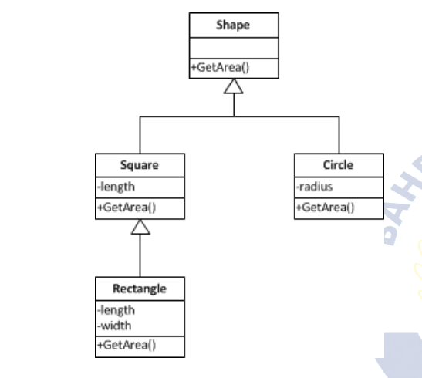

**Solution:**

package oop_lab_8;

public class OOP_LAB_8 {

public static void main(String[] args) {

Shape s1 = new Shape();

s1.getArea(); //Calling method from Shape Class

Square s = new Square(4.5);

s.getArea(); //Calling method from Square Class

Rectangle r = new Rectangle(6,8);

r.getArea(); //Calling method from Rectangle Class

Circle c = new Circle(2.3);

c.getArea(); //Calling method from Circle Class

}

}

package oop_lab_8;

public class Shape {

public void getArea(){

System.out.println("The Area of Shape will be shown here !");

}

}

package oop_lab_8;

public class Square extends Shape{

private double length;

public Square(){

this.length=0;

}

public Square(double l){

this.length=l;

}

public void getArea(){

System.out.println("\nThe Area of Square is: "+this.length*this.length);

}

}

package oop_lab_8;

public class Rectangle extends Square{

private double length;

private double width;

public Rectangle(){

this.length=0;

this.width=0;

}

public Rectangle(double length, double width){

this.length=length;

this.width = width;

}

public void getArea(){

System.out.println("\nThe Area of Rectangle is: "+this.length*this.width);

}

}

package oop_lab_8;

public class Circle extends Shape{

private double radius;

public Circle(){

this.radius=0;

}

public Circle(double r){

this.radius=r;

}

public void getArea(){

System.out.println("\nThe Area of Circle is: "+Math.PI*this.radius*this.radius);

}

}

